**Export your Apple Push certificate from Keychain Access**

Launch Keychain Access on your Mac. Find the iOS push certificate for your app in the "My Certificates" section of Keychain Access. Its name will begin with "Apple Development IOS Push Services". If you expand the certificate row in Keychain Access, **it should contain your private key**. Select both the certificate and the key it contains, then right click, and choose "Export".

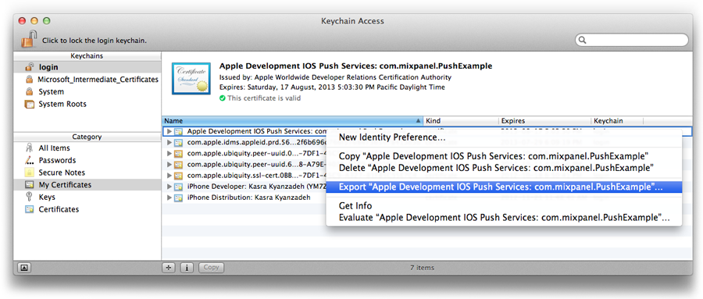

When prompted for the file format, select "Personal Information Exchange (.p12)".

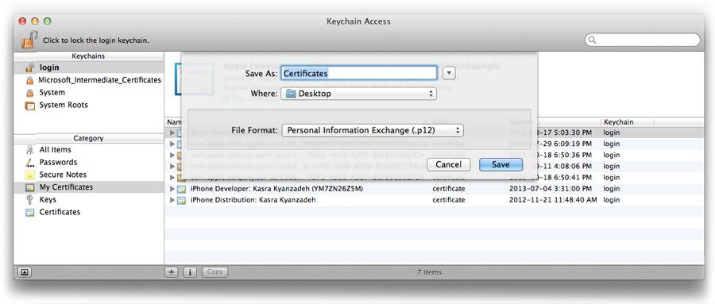

When prompted for a password to protect the exported items, **do not enter a password**. This will let us read your certificate once you upload it. You may be asked for your keychain password afterwards. Enter your password in this second dialog.

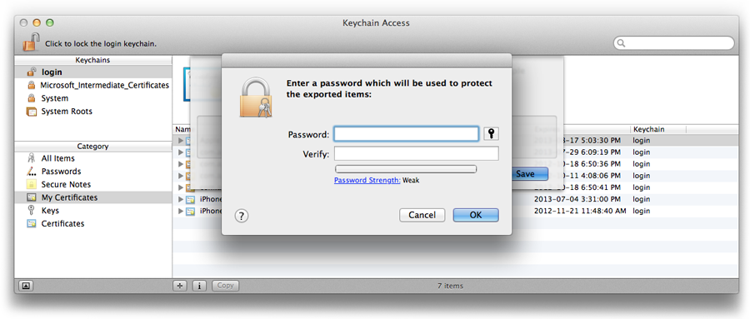

Extract the pem file from the p12 file:

`openssl pkcs12 -nodes -clcerts -in path/to/Certificates.p12 -out development.pem`